Monitoring

* + What are your goals for monitoring?
  + What resources you will monitor?
  + How often you will monitor these resources?
  + What monitoring tools will you use?
  + Who will perform the monitoring tasks?
  + Who should be notified when something goes wrong?
* Automate monitoring tasks as much as possible.
* Check the log files on your EC2 instances.

AppDynamics

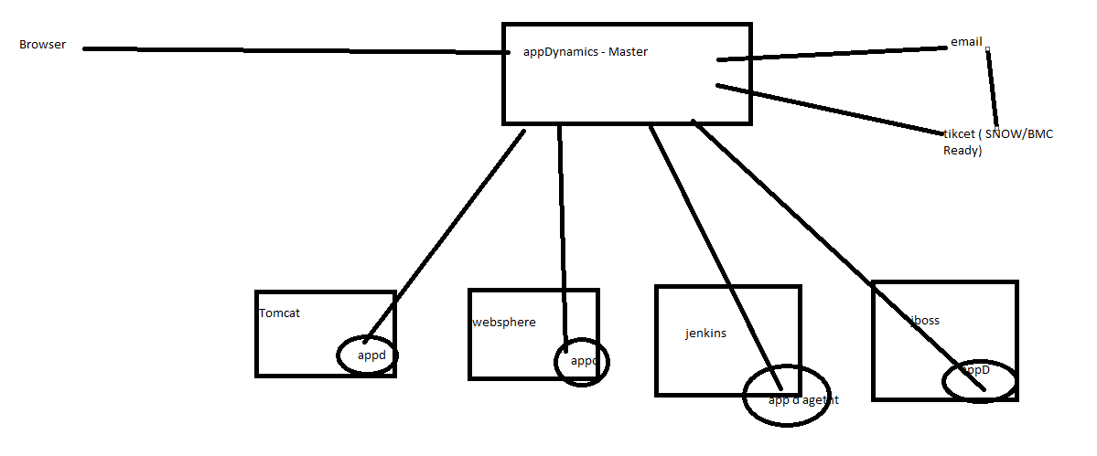

AppDynamics will have different agents.

1)Application agent - checks application performance ( jvm usage, garbage collection, threads count , request count, slow request ,db calls , total calls, time taken to process..)

2)Machine agent - checks cpu usage , memory usage ,disc usage , process check..etc.

<https://www.appdynamics.com/solutions/cloud-monitoring/>

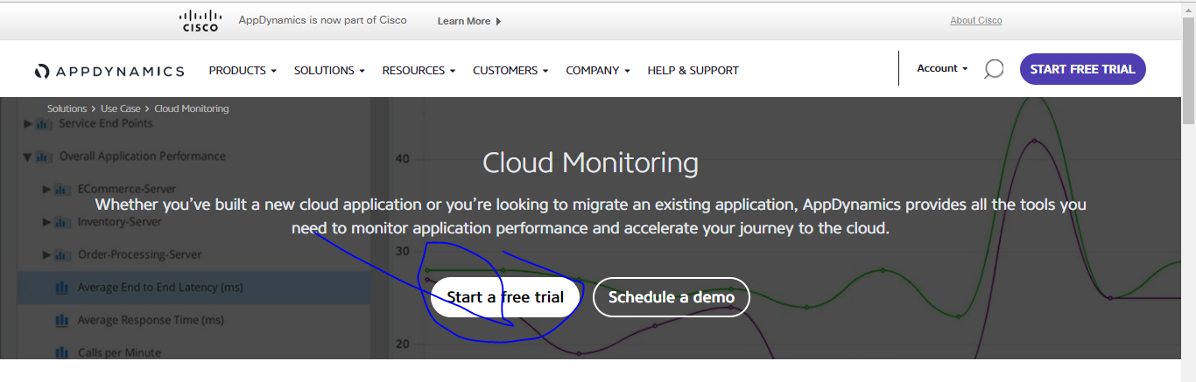

Fill the form and use dummy email id to login.

Next select

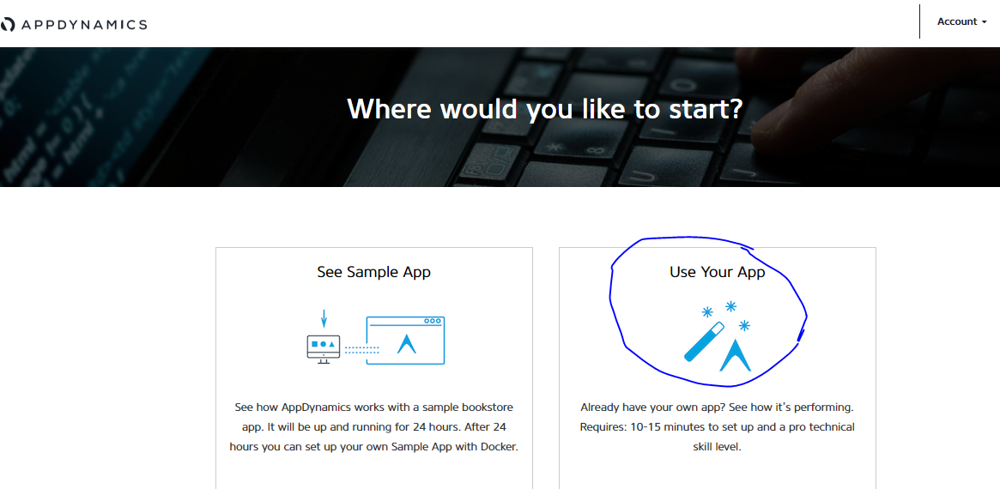

It gives you one SaaS url with already setup master server.

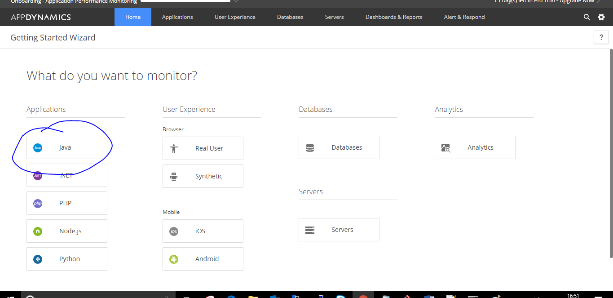

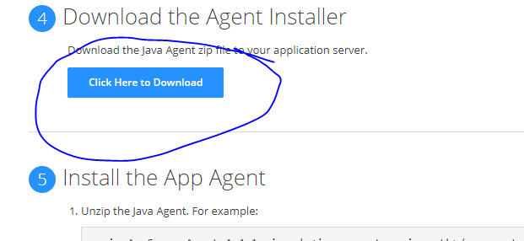

Upload the agent into s3. From s3 download the file into your local server. ( where ever tomcat runs into that server).

To download from s3 your machine requires iam role with s3 full access( policy and role).

Createing IAM role.

Goto IAM section and

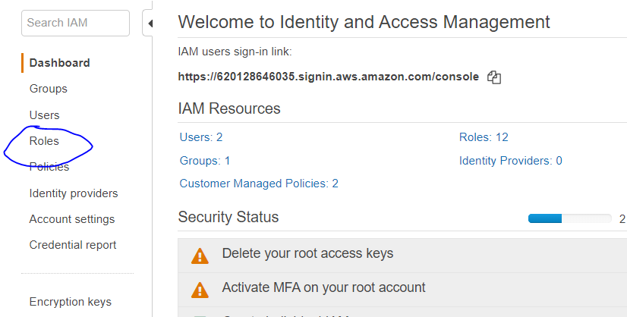

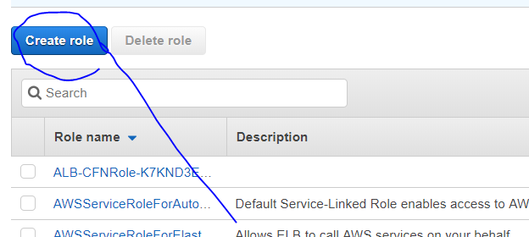

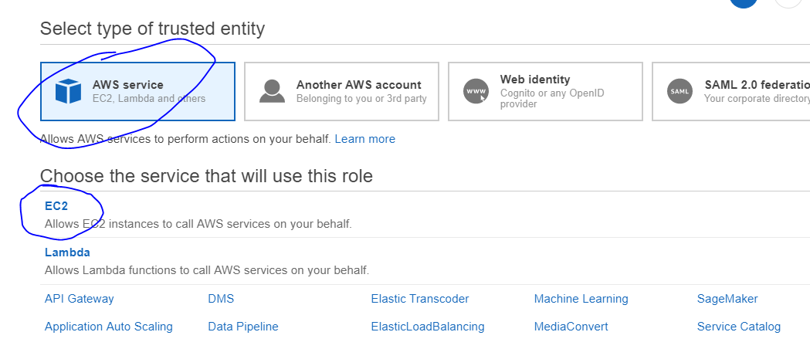

Click on Next.

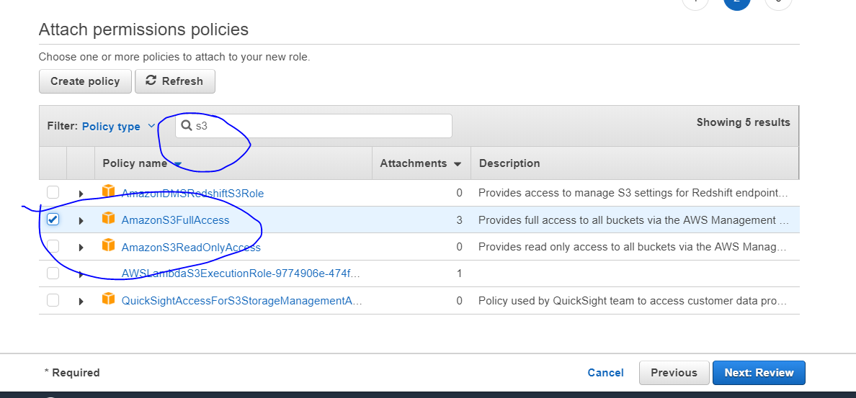

Click on Review

Provide Role Name : common-softwares.

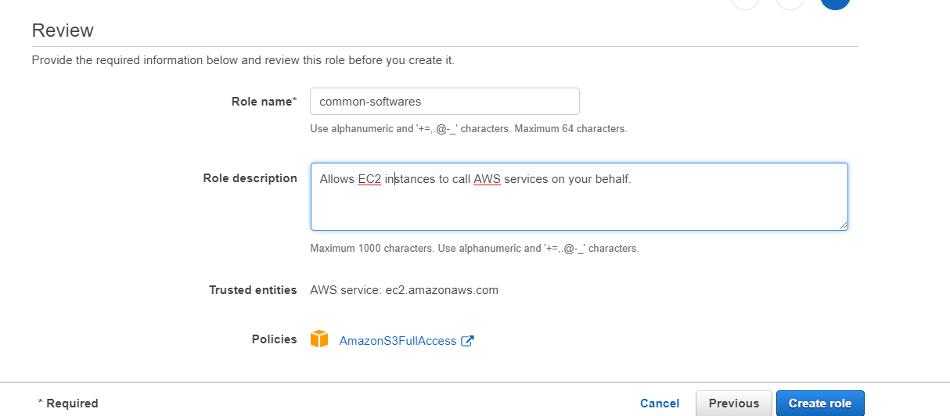

Click on Create Role.

Assign the role to ec2 machine.

Select the ec2 machine  and actions

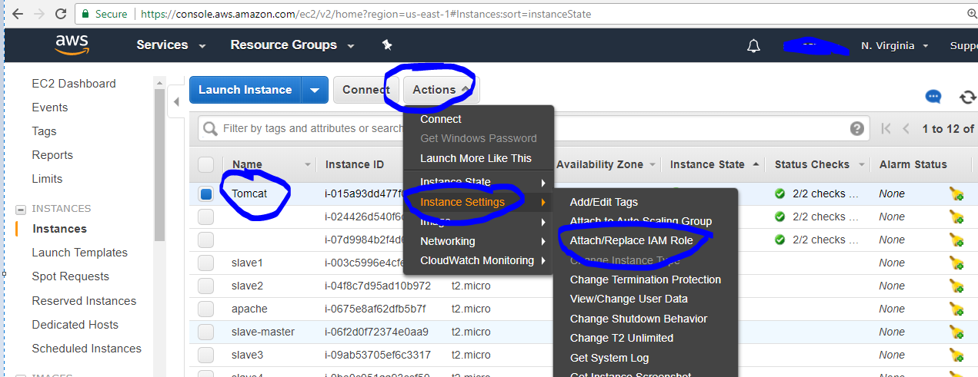

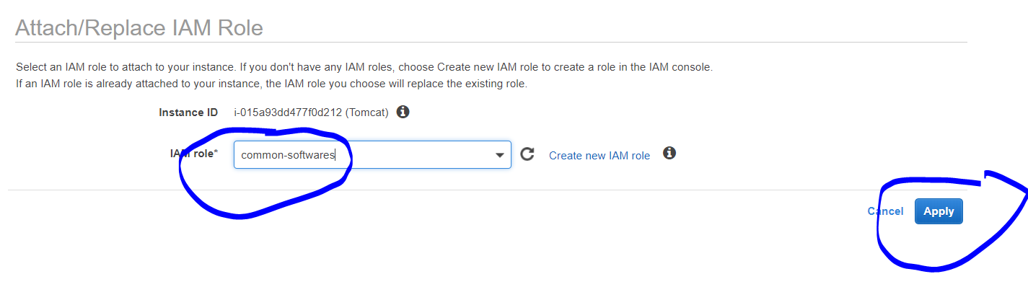

In S3 bucket make the appD agent as public and copy the url.

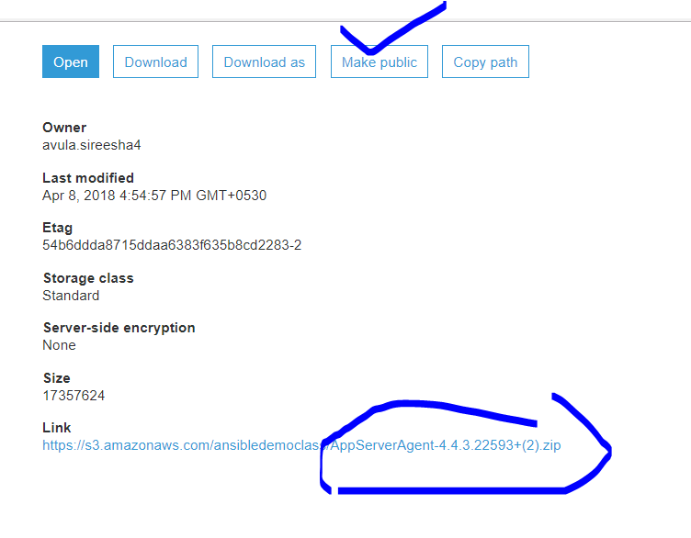

Login to the ec2 machine .

Ssh -i <pemfilename>.pem ec2-user@publicip

Switch to root user ( sudo su -)

Goto /opt folder and create directory.

mkdir appdynamics

Wget <s3 appd agent url>

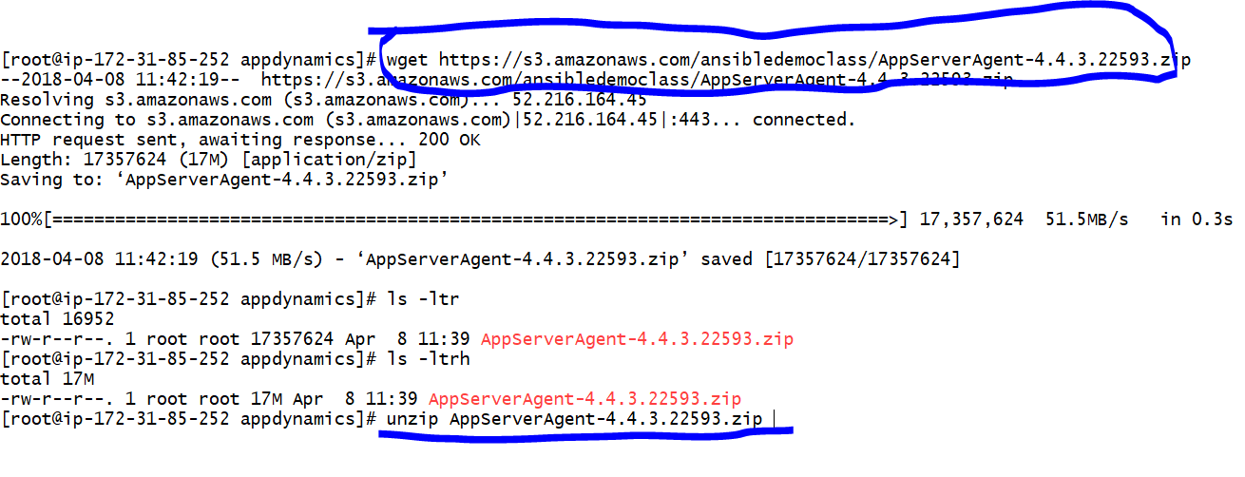

Unzip <filename>.zip

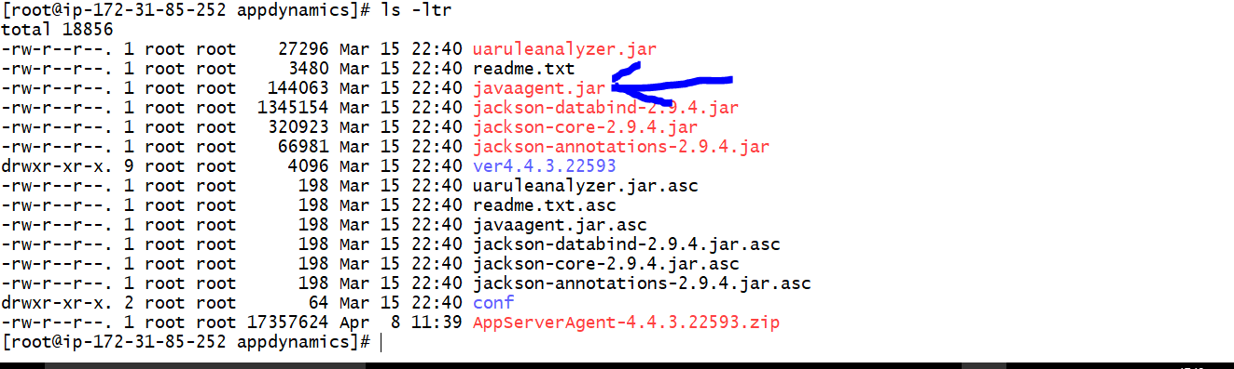

Goto tomcat/bin folder and in setenv.sh create the lines as below.

Instrument Apache Tomcat

1. Open (or create if it doesn't already exist) the setenv.sh (Linux) or setenv.bat (Windows) file. For Tomcat 6 and later, you can put the file in the CATALINA_BASE/bin directory. For previous versions of Tomcat, put the file in the CATALINA_HOME/bin directory
2. Add the -javaagent argument to the file as a Catalina environment variable, as follows.
3. **On Linux:**

|  |
| --- |
| 1. export CATALINA_OPTS="$CATALINA_OPTS -javaagent:<agent_home>/javaagent.jar" |

• Replace <agent_home> with the full path to the Java Agent JAR file.

•

• For example:

|  |
| --- |
| 1. export CATALINA_OPTS="$CATALINA_OPTS -javaagent:/home/appserver/appagent/javaagent.jar" |

• **On Windows:**

|  |
| --- |
| 1. set CATALINA_OPTS=%CATALINA_OPTS% -javaagent:"Drive:<agent_home>\javaagent.jar" |

• For example

|  |
| --- |
| 1. set CATALINA_OPTS=%CATALINA_OPTS% -javaagent:"C:\appagent\javaagent.jar" |

• Restart the application server. The application server must be restarted for the changes to take effect.

Instrument Tomcat When Running as a Windows Service

When running Tomcat as a Windows service, add the javaagent argument to your Tomcat startup properties. These instructions apply to Apache Tomcat 6.x or later versions.

**To install the Java agent in Tomcat running as a Windows service**

1. Ensure that you are using administrator privileges.
2. Click **Programs > Apache Tomcat** > **Configure Tomcat.**
3. Click the **Java** tab and in the **Java Options** add:

|  |
| --- |
| 1. -javaagent:"<agent_home>\javaagent.jar" |

• Restart the Tomcat service to have the changes take effect.

After updating the setenv.sh, Allow the 443 port number to connect from appDynamics controller to appD agent.( security group in inbound rules , 443 from anywhere.)

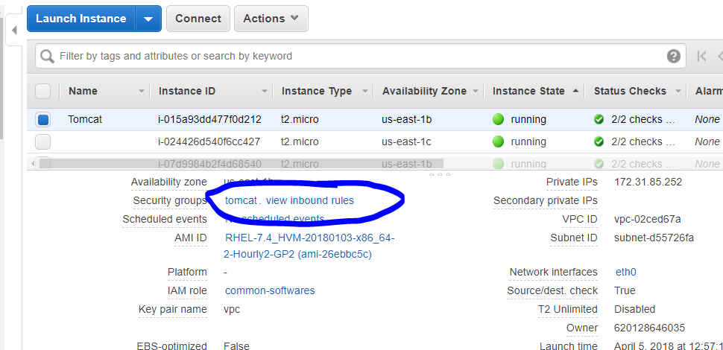

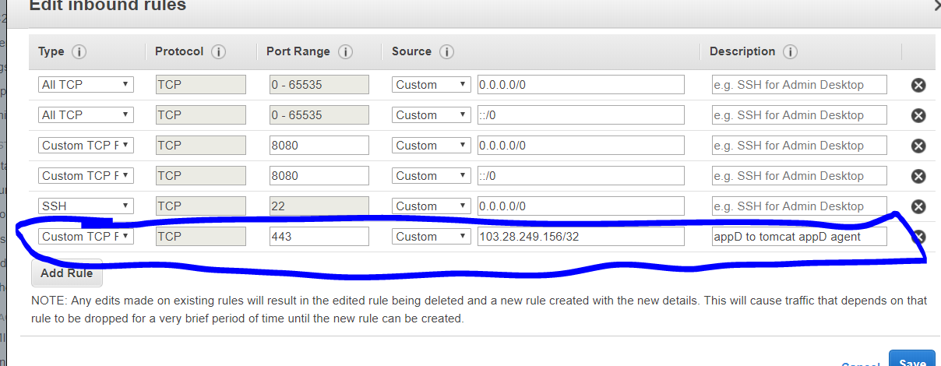

Now restart the tomcat.

And check the catalina.out log if any errors or connectivity info for the success to appD controller.

CATALINA_HOME/bin/shutdown.sh

CATALINA_HOME/bin/startup.sh

CATALINA_HOME/logs/catalina.out ( tail -500f catlina.out)

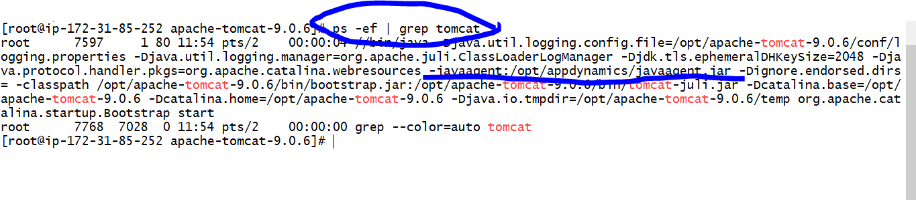

grep -i appdynamics catalina.out

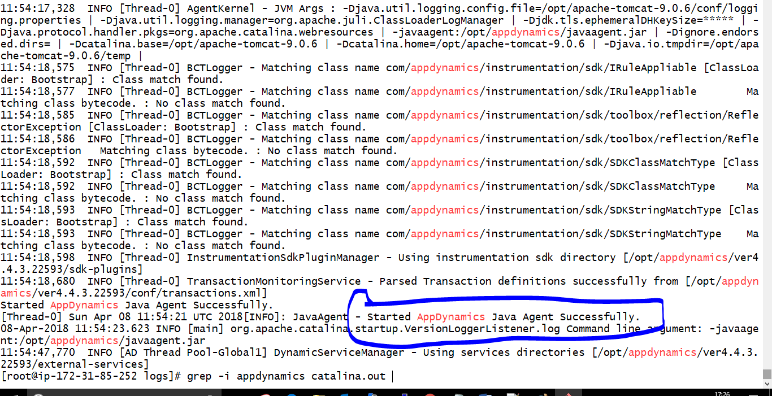

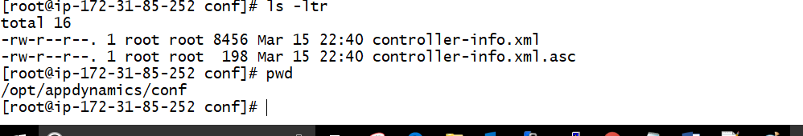

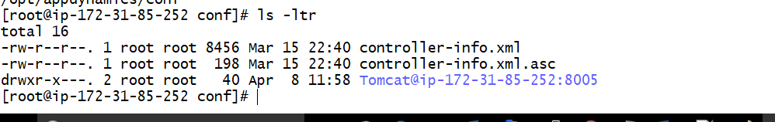

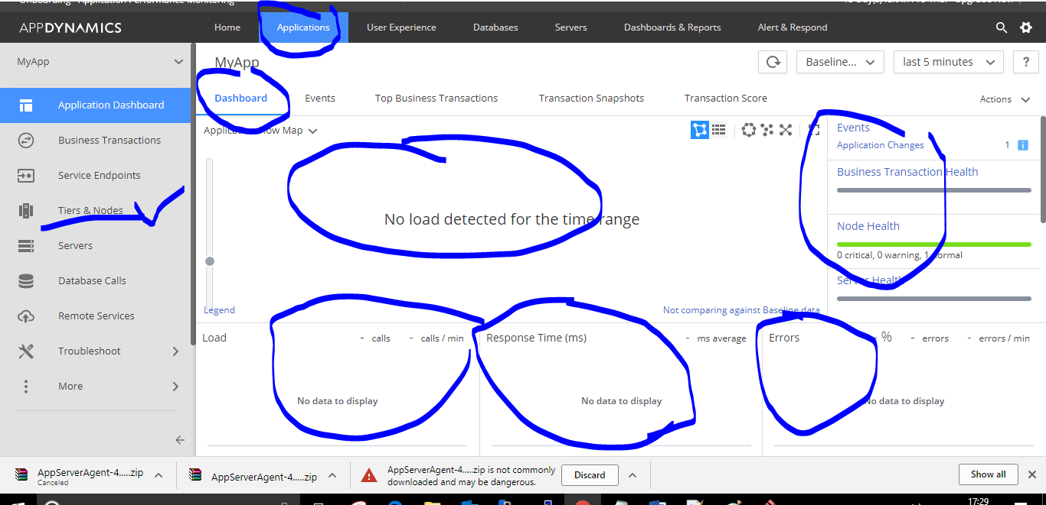

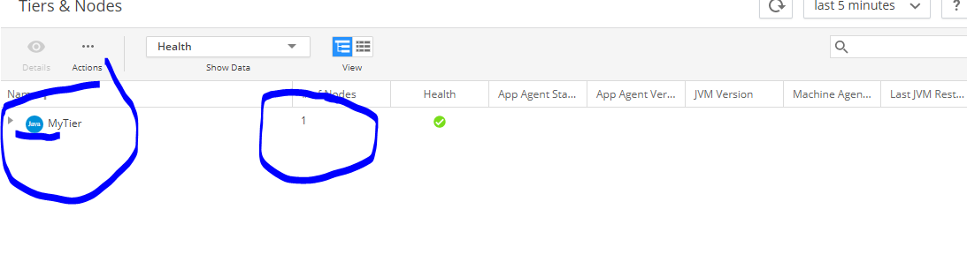

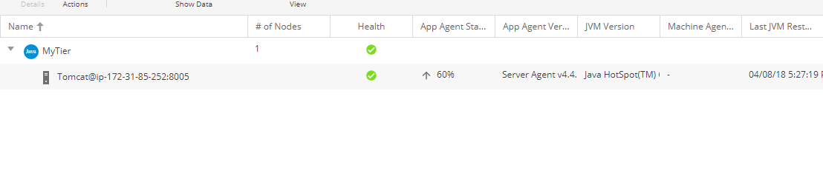

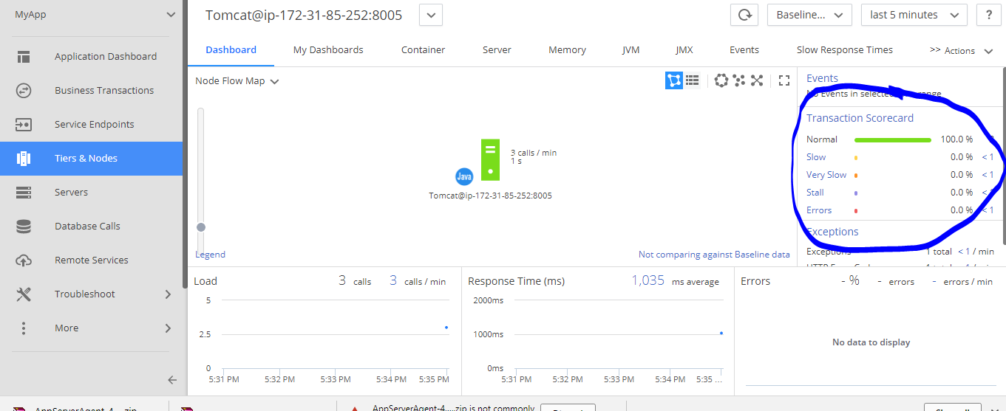

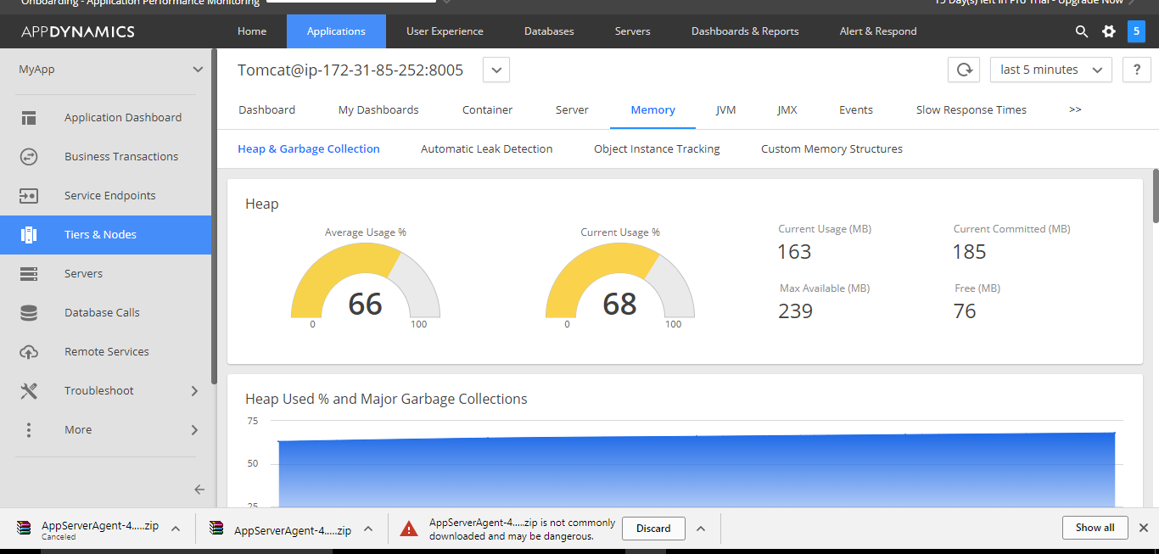

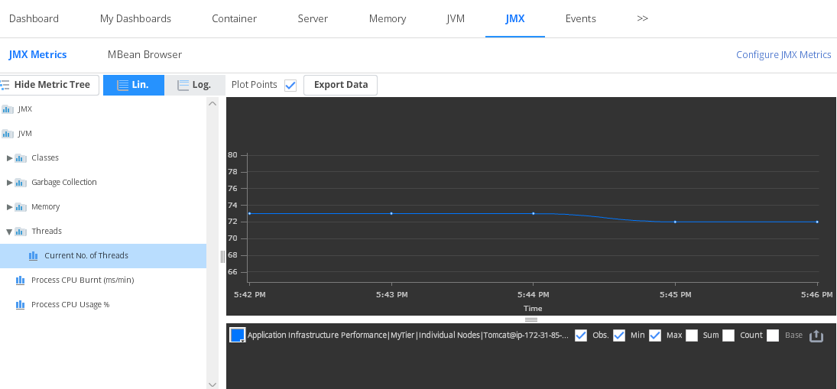

Machine Agent :

AppDynamics Server Visibility gives you comprehensive insight into the performance of your Servers, including CPU, Memory, Disks, Networks, Processes, and more.

Server Visibility requires a Standalone Machine Agent on each server of interest. If you have .NET agents installed, you can view basic machine metrics in the Node Dashboard.

You can view basic hardware metrics in Applications - Tiers & Nodes - Node Details - Server.

**Get Started**

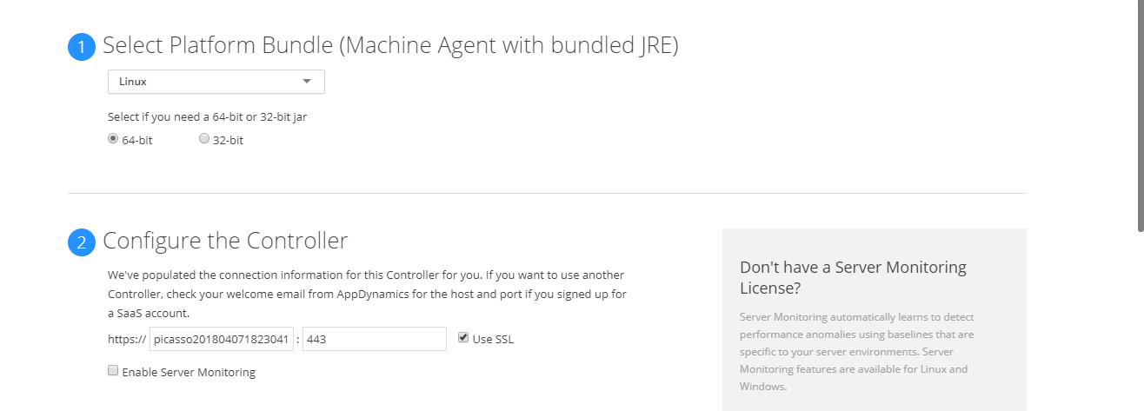

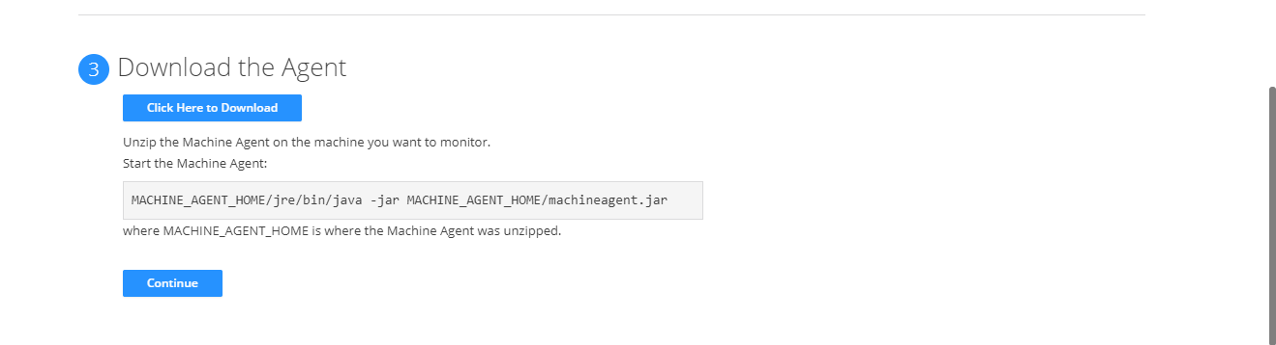

**j**

Upload the machine agent into s3 and download into the server.

In the server

/opt/

Mkdir appmachine

And download the agent with wget. Exact the zip.

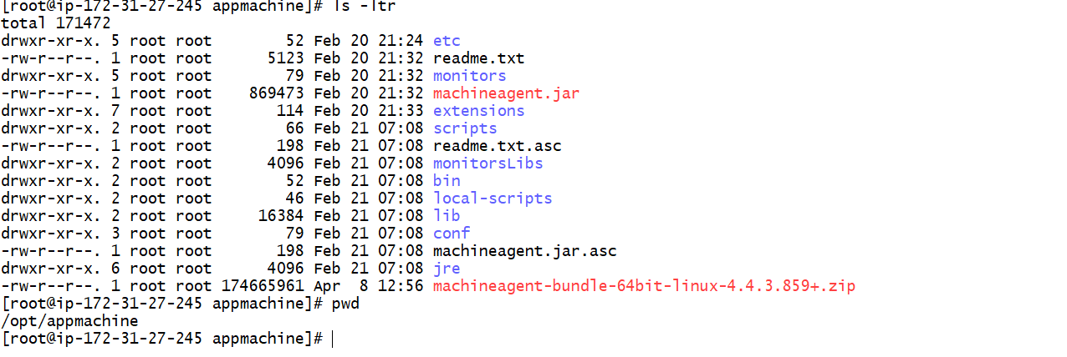

[root@ip-172-31-27-245 scripts]# cat machineagent.sh

**nohup /opt/appmachine/jre/bin/java -jar /opt/appmachine/machineagent.jar &**

[root@ip-172-31-27-245 scripts]#

**Nagios:**

<https://www.tecmint.com/install-nagios-in-linux/>

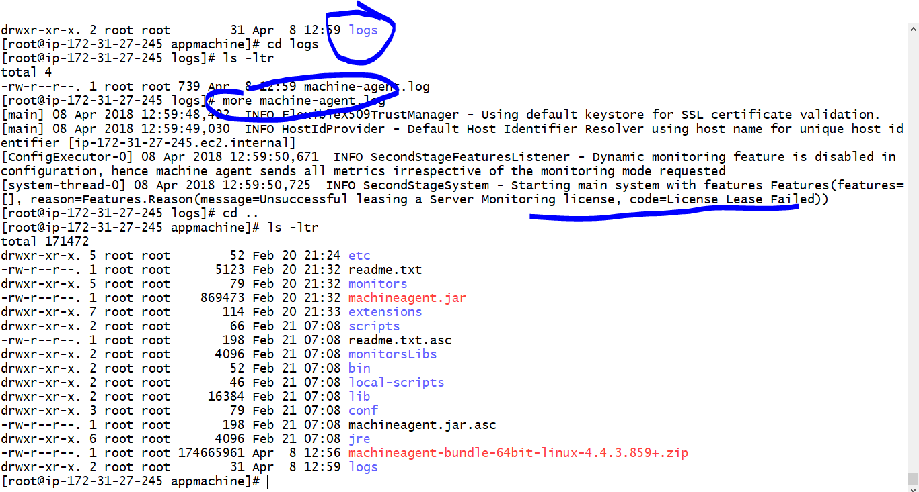

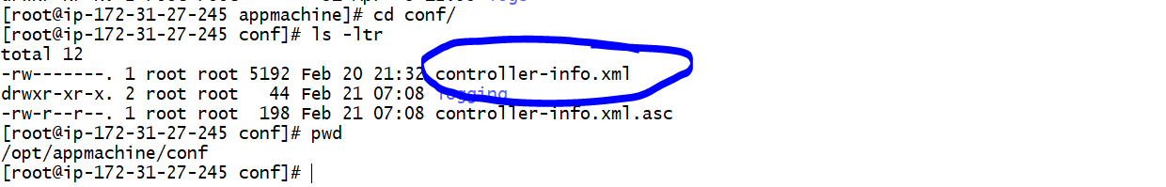

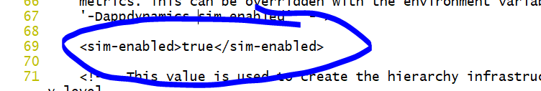

Nohup

